UNLEY SPORTING CLUB, 8 NORTHGATE ST, UNLEY PARK

JEUDI 21 Mars – de 18h à 20h

Tournoi de Pétanque 2024
des Écoles primaires (années 3 à 6) et secondaires (années 7 à 10)

How to enter:
- Choose teams of between 2 – 4 players from your school students.
Please note that two teams per school are allowed to enter (For example; 2 teams per primary school and 2 teams per high school. Country schools may enter 3 teams per school)
- Click on the QR code below to register your teams by FRIDAY 15 MARCH
Please note that one teacher per participating school must be a member of SAFTA to enter teams in the competition. Please use the link below to become a member of SAFTA and join our wonderful French teaching community!

Pétanque team registration:
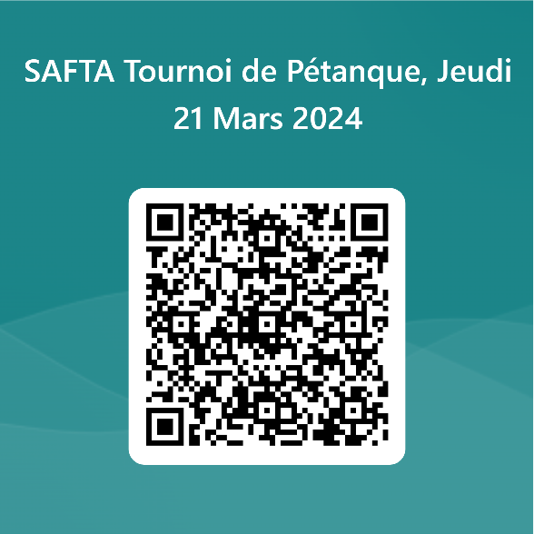

Link to Educators SA to become a SAFTA member:
https://educators-sa.sa.edu.au/directory/south-australian-french-teachers-association-inc/

